**Design and Development of Active Face Recognition System for Attendance**

**A** **PROJECT REPORT**

Submitted in partial fulfillment of the requirements for the degree of

**BACHELOR OF TECHNOLOGY**

In

**COMPUTER SCIENCE & ENGINEERING**

**PREPARE**

By

# 0187CS221003 Aavi Agrawal

# 0187CS221022 Adnan Baig

# 0187CS221027 Akash Prajapati

# 0187CS221001 Aakash Tiwari

# 0187CS221054 Arhama Khan

# 0187CS233D01 Divya Dhanwani

### Under the guidance of

**Prof. Bhawna Soni Assistant Professor**



### October-2024

**Department of Computer Science & Engineering Sagar Institute of Science & Technology (SISTec) Bhopal (M.P.)**

**Approved by AICTE, New Delhi & Govt. of M.P.**

**Affiliated to Rajiv Gandhi Proudyogiki Vishwavidyalaya, Bhopal (M.P.)**

**INDEX**

1. INTRODUCTION:

1.1 PURPOSE.

1.2 PRODUCT SCOPE.

1.3 DEFINITION.

1. TECHNOLOGIES TO BE USED:

### HARDWARE REQUIREMENTS.

### SOFTWARE REQUIREMRNTS.

### OVERALL DESCRIPTION:

### 3.1 PRODUCT PERSPECTIVE.

### 3.2 USER CLASSES AND CHARACTERISTICS.

### 3.3 OPERATING ENVIRONMENT.

### 3.4 SOFTWARE INTERFACE.

### 3.5 HARDWARE INTERFACE.

### DESIGN:

### 4.1 SYSTEM DESIGN.

### 4.2 USE CASE DIAGRAM.

### 4.3 CLASS DIAGRAM.

### 4.4 WEB CAM STATE CHART DIAGRAM.

### 4.5 DATA FLOW DIAGRAM.

### 4.6 ER DIAGRAM.

### CONCLUSION:

### REFERENCE

**ACTIVE FACE RECOGNITION**

1. **INTRODUCTION:-**

### PURPOSE

The primary purpose of this project is to develop a robust and efficient system for

Automating the attendance tracking process through facial recognition technology.

By leveraging real-time database integration, this system aims to provide a seamless

and accurate solution for monitoring and recording attendance in various educational

or organizational settings.

* 1. **PRODUCT SCOPE**

**Facial Recognition Module:**

1. Implementation of a robust facial recognition system for identity verification.
2. Integration of face detection and recognition algorithms to accurately identify

individuals.

**Real-Time Database Integration:**

1. Integration with a real-time database system (e.g., Firebase) to store attendance data securely and efficiently.
2. Real-time synchronization of attendance records for immediate access by

authorized users.

**User Interfaces:**

Development of user-friendly interfaces for different user roles. Attendee

interface for marking attendance using facial recognition.

**Authentication and Authorization:**

1. User authentication and authorization mechanisms to control access and

permissions.

1. Secure access for administrators to manage attendance data.

**Reporting and Analytics:**

1. Generation of absentee reports.

**Scalability:**

1. Design for scalability to accommodate varying numbers of attendees and check-in points.
   1. **DEFINITION**

A face attendance system using a real-time database is a computer system that uses facial recognition technology to identify and verify the faces of individuals in real time, and store their attendance data in a database. The system can be used to track attendance in a variety of settings, such as schools, offices, and factories but here we will be using it for schools.

The system typically works as follows:

* A camera captures a video stream of the individuals whose attendance is to be taken.
* The face detection algorithm in the system identifies and locates the faces in the video stream.
* The face recognition algorithm in the system compares the detected faces to the faces in the database.
* If a match is found, the system marks the individual as present and stores their attendance data in the database. Otherwise, the system marks the individual as absent.
* The real-time database ensures that the attendance data is always up-to-date and can be accessed by authorized admin at any time.
* The system ensures that is the student is absent then an automatic email should be sent to the registered mail id informing the parents that he/she is not attending the classes.

1. **TECHNOLOGIES TO BE USED:-**
   1. **HARDWARE REQUIREMENTS**

1. A computer with an embedded camera/webcam.

2. A network connection to the database server.

* 1. **SOFTWARE REQUIREMRNTS**

1. A programming language such as Python.

2. A face detection library such as OpenCV.

3. A face recognition library such as face recognition.

4. A back-end service (Firebase) for providing real time data base.

1. **OVERALL DESCRIPTION:-**
   1. **PRODUCT PERSPECTIVE**

The product perspective for a face attendance system using areal-time database is to provide a convenient, accurate, and reliable way to track attendance in schools or colleges.

The system should be able to identify and verify the faces of individuals in real time, and store their attendance data in a database. The system should be able to generate the report at the end of the end of the attendance and send mails to the absentees.

The system should also be secure and reliable. The database should be protected from unauthorized access, and the system should be able to handle a large number of user and transactions without any problem.

* 1. **USER CLASSES AND CHARACTERISTICS**

1. **Student:** Students in middle and high schools, as well as college

and university student.

1. **Employees:** Employees in offices, factories, retail stores, and other

workplaces.

1. **Event Attendees:** Attendees at conferences, trade shows, concerts, and other

events.

1. **Administrators:** System administrators who are responsible for adding, editing,

And deleting user accounts from the database, as well as

generating reports on attendance data.

* 1. **OPERATING ENVIRONMENT**

The operating environment of a face attendance system using areal-time database can vary depending on the specific setting in which the system is used. However, some common operating environment requirements include:

* **Hardware:**
* A computer embedded with a camera/webcam(recommended webcam-Logitech HD pro webcam).
* **Software:**
* Visual Studio Code as the IDE.
* A programming language-python.
* Libraries used-tkinter, dlib, face_recognition, cv2, opencv-python.
* **Other requirements:**
* A stable power supply.
* A reliable network connection.
* A secure environment.
  1. **SOFTWARE INTERFACE**

The software interface required for developing a face attendance system using a real-time database will vary depending on the specific features and requirements of the system. However, some common elements include :

1. **Attendance tracking screen:**

An attendance tracking screen where user scan mark their attendance.

• It includes the Face Registration Screen with camera view on the left

pane.

• After the face recognition, it shows the details of the student on the

right pane, which include the Name of the student, Roll number,

Branch ,Current Year and the current updated attendance.

• After marking the attendance, it shows ‘MARKED’.

• If same face is detected again, it shows ‘ALREADYMARKED’

1. **Reporting Screen:**

A reporting screen where administrators can view reports on attendance data.

• This is basically for the administrator’s view, which shows the

details of all the students and their respective attendance including

the last attendance time.

* 1. **HARDWARE INTERFACE**

The hardware interface of a face attendance system using areal-time database typically consists of the following components:

1. **Camera:** A camera/webcam is used to capture images of the faces of individuals. The camera should be high-resolution and have a wide field of view to ensure that it can capture clear images of faces from a variety of angles and distances. (recommended webcam-Logitech HD pro webcam).
2. **Computer/Laptop:** A computer/laptop is used to run the face detection and recognition algorithms.
3. **Network connection:** A network connection is required to connect the device to the real-time database. The network bandwidth and latency requirements will depend on the number of users and the amount of data being transferred.
4. **DESIGN:**
   1. **SYSTEM DESIGN**

The system design for a face attendance system using a real-time database should be carefully considered to ensure that the system is reliable, scalable, and secure. The system should be able to handle a large number of concurrent users and it should be able to accurately detect and recognize faces in a variety of lighting conditions and from a variety of angles. Front-end part of the system consist of the interface visible to the user. The designing part of the various modes like the background image Attendance system, display of the details, Marked window, Already Marked window, is done using Canva.

* 1. **USE CASE DIAGRAM**

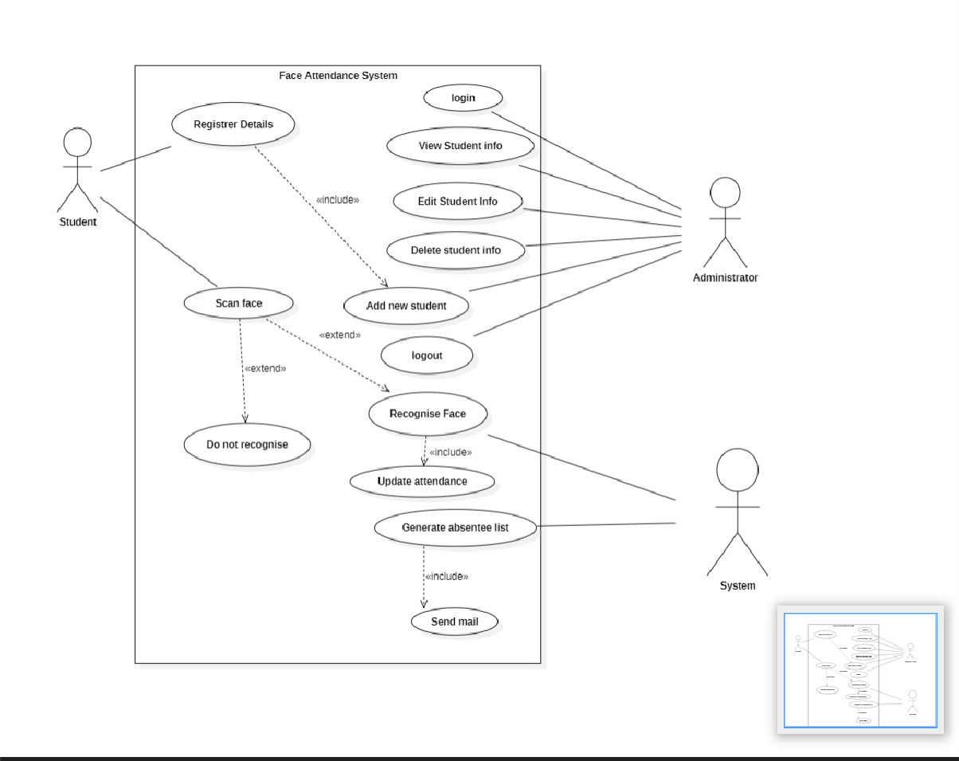

* 1. **CLASS DIAGRAM**

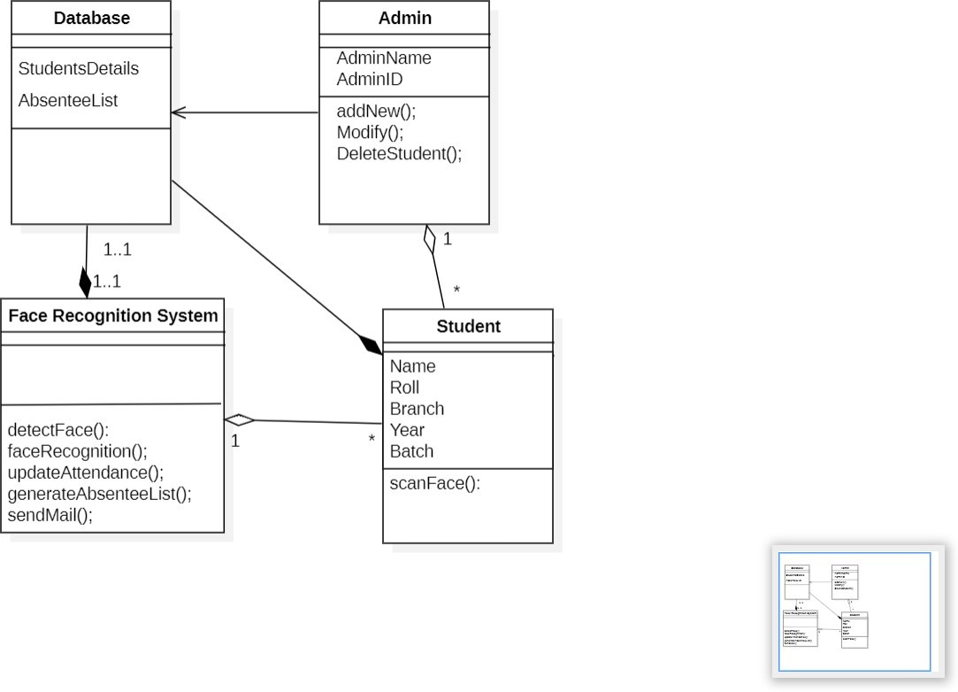

* 1. **WEB CAM STATE CHART DIAGRAM**

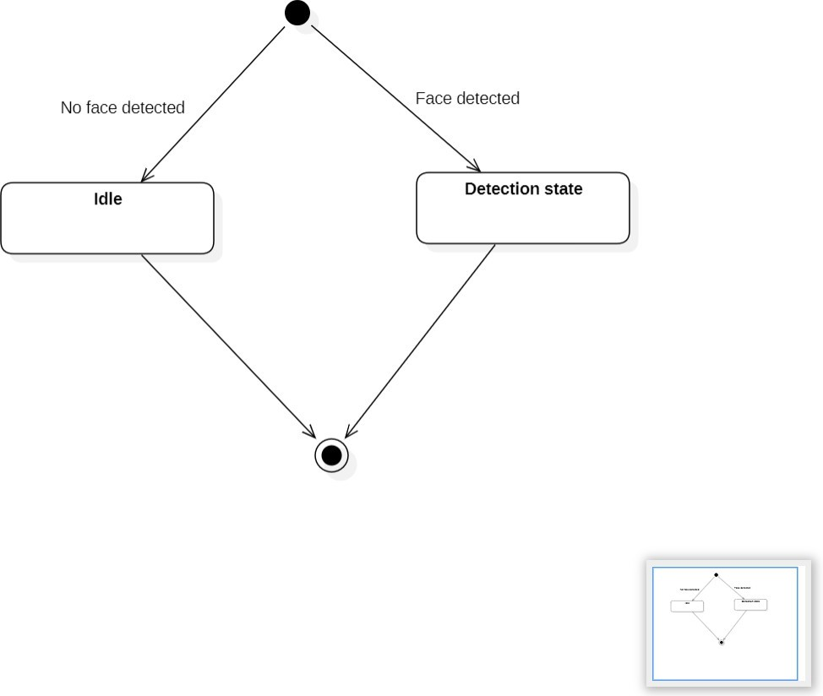

* 1. **DATA FLOW DIAGRAM**

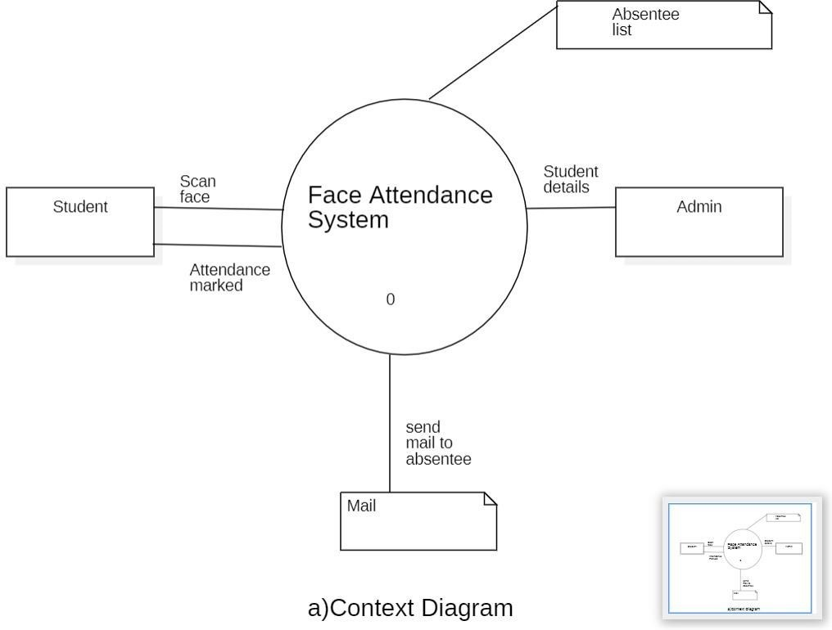

* 1. **ER DIAGRAM**

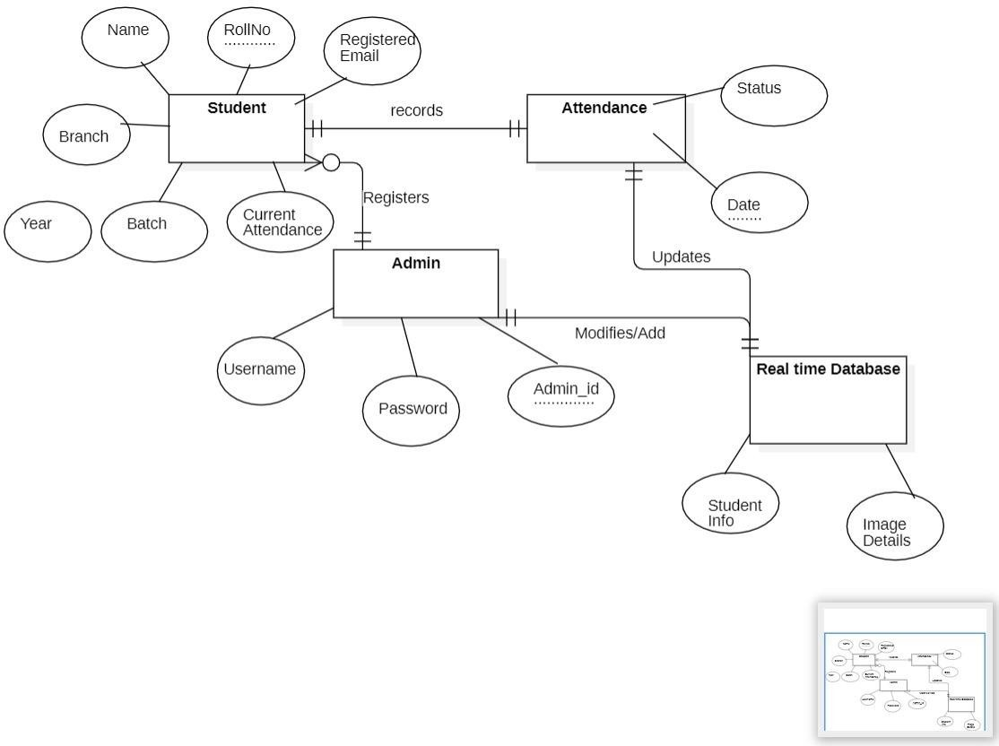

1. **CONCLUSION:**

In conclusion, the face attendance system using a real time database is a powerful tool that can help schools to improve attendance tracking, save time, and improve student engagement. The system is convenient, accurate, reliable, and secure, and it can be integrated with other school systems to provide a more complete view of student progress.

The face attendance system offers a number of benefits for schools, including:

1. **Improved attendance tracking:**

The system provides an accurate and reliable way to track student attendance. This can help schools to identify students who are at risk of dropping out or who need additional support.

1. **Time Savings:**

The system saves teachers time by automating the attendance tracking process. This allows teachers to focus on other important tasks, such as teaching and preparing lessons.

1. **Improved student engagement:**

The system can be used to engage students in their learning by providing them with feedback on their attendance or by rewarding them for good attendance.

1. **REFERENCES:**

* [**https://www.geeksforgeeks.org/opencv-python-program-face-detection/**](https://www.geeksforgeeks.org/opencv-python-program-face-detection/)
* [**https://www.researchgate.net/publication/326986115_Face_Detection_and_Recognition_Student_Attendance_System**](https://www.researchgate.net/publication/326986115_Face_Detection_and_Recognition_Student_Attendance_System)
* [**https://youtu.be/BYCKvM8eZGA?si=QEvUw4VYFg4-4IrO**](https://youtu.be/BYCKvM8eZGA?si=QEvUw4VYFg4-4IrO)
* [**https://machinelearningprojects.net/face-recognition-based-attendance-system/**](https://machinelearningprojects.net/face-recognition-based-attendance-system/)